**Title**

# VBA Stock Data Analysis Project

Table of Contents

**Title** 1

VBA Stock Data Analysis Project 1

**Project Overview** 3

**Repository Structure** 4

**Instructions** 4

**Prerequisites** 4

**Getting Started** 4

**Script Overviews** 6

**Single Quarter Stock Analysis** 6

**Multiple Year Stock Analysis** 8

**Sample Output** 10

**Single Quarter Stock Analysis** 10

Multiple Year Stock Data 12

Summary sheet displays: 14

alphabetical_testing 14

Multiple Year Stock Data Analysis 16

Conclusion 16

References 17

**Project Overview**

#### Single Quarter Stock Analysis

The Single Quarter Stock Analysis script is designed to automate the analysis of stock data within a single worksheet for a given quarter. The script reads stock data, calculates key financial metrics such as the quarterly change, percentage change, and total volume for each stock ticker, and outputs these results into a summary table. By automating these calculations, the script streamlines the process of financial analysis, allowing users to quickly and accurately assess the performance of various stocks. Additionally, the script applies conditional formatting to the results, highlighting positive changes in green and negative changes in red, which enhances the readability and interpretability of the data. This script is particularly useful for analysts and investors who need to perform detailed quarterly assessments of stock performance within a large dataset.

#### Multiple Year Stock Analysis

The Multiple Year Stock Analysis script extends the functionality of the Single Quarter Stock Analysis by processing stock data across multiple worksheets, each representing different quarters or years. This script iterates through each worksheet in the Excel workbook, performing the same calculations as the single quarter script but on a larger, multi-period dataset. It calculates the quarterly change, percentage change, and total volume for each stock ticker, compiling the results into summary tables for each worksheet. Furthermore, the script identifies and outputs the stocks with the greatest percentage increase, greatest percentage decrease, and greatest total volume across all periods analyzed. Conditional formatting is also applied to highlight positive and negative changes. This comprehensive analysis tool is invaluable for financial analysts and investors who need to track and compare stock performance over multiple periods, providing a holistic view of market trends and individual stock movements.

**Repository Structure**

markdown

Copy code

VBA-challenge/

│

├── Module 2 Challenge files/

│ ├── alphabetical_testing.xlsx

│ └── ...

│

├── SingleQuarterStockAnalysis.bas

├── MultipleYearStockAnalysis.bas

├── README.md

**Instructions**

**Prerequisites**

* Microsoft Excel
* Basic knowledge of VBA (Visual Basic for Applications)

**Getting Started**

1. **Clone the Repository**

bash

Copy code

git clone https://github.com/yourusername/VBA-challenge.git

cd VBA-challenge

1. **Open Excel and Load VBA Scripts**
   * Open Excel and press Alt + F11 to open the VBA editor.
   * Import the SingleQuarterStockAnalysis.bas and MultipleYearStockAnalysis.bas files by going to File > Import File... in the VBA editor.
   * Load the alphabetical_testing.xlsx file from the Module 2 Challenge files directory for testing purposes.
2. **Run the Scripts**
   * Close the VBA editor and go back to the Excel workbook.
   * To run the Single Quarter Stock Analysis script, press Alt + F8, select SingleQuarterStockAnalysis, and click Run.
   * To run the Multiple Year Stock Analysis script, press Alt + F8, select MultipleYearStockAnalysis, and click Run.

**Script Overviews**

**Single Quarter Stock Analysis**

This script processes stock data for a single quarter in the current worksheet.

**Key Steps:**

1. **Initialize Variables:**
   * Declares variables for ticker symbols, quarterly change, percentage change, total volume, and tracking the greatest values.

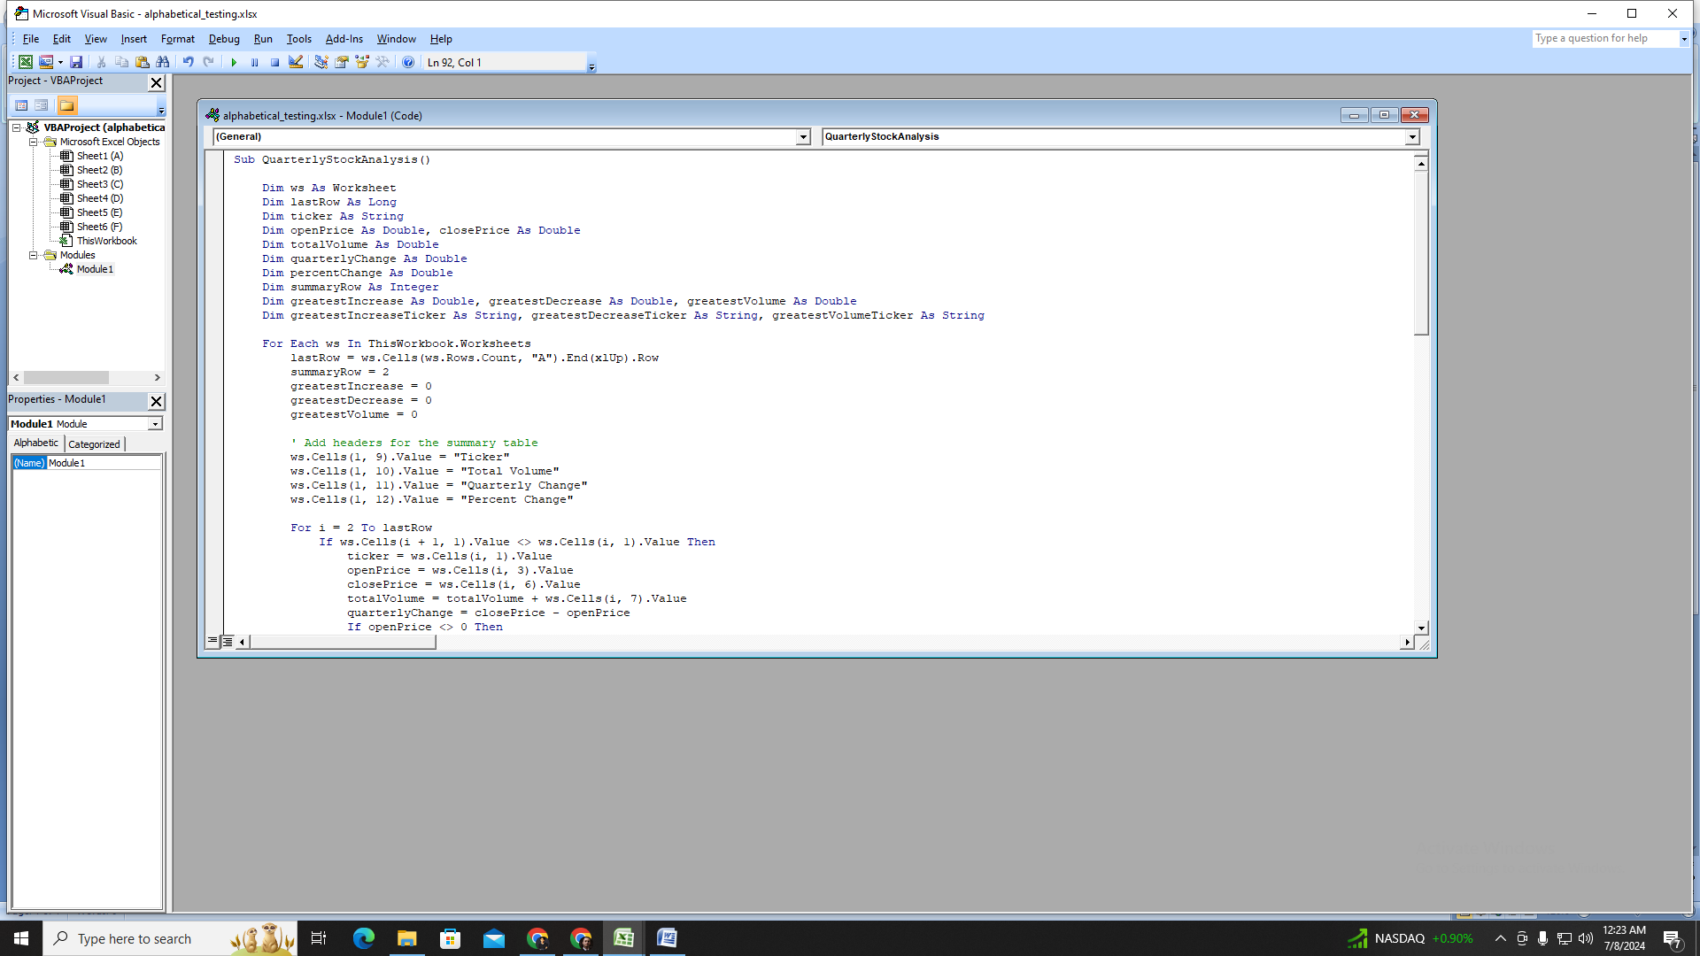

1. **Process Each Row:**
   * Loops through each row of data in the current worksheet.
   * Accumulates the total volume for the current ticker.
   * Calculates the quarterly change and percentage change when the ticker changes or the last row is reached.
   * Writes the results to the summary table and applies conditional formatting.

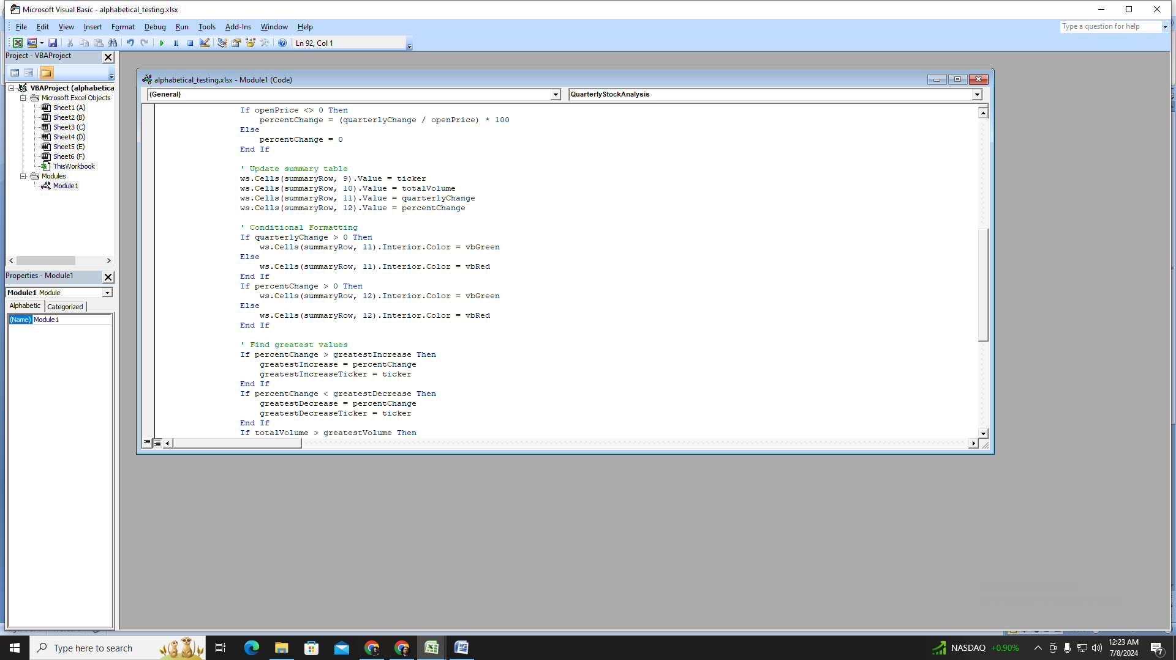

1. **Identify Greatest Values:**
   * Determines the greatest percentage increase, greatest percentage decrease, and greatest total volume.
   * Outputs these values in a designated summary section.

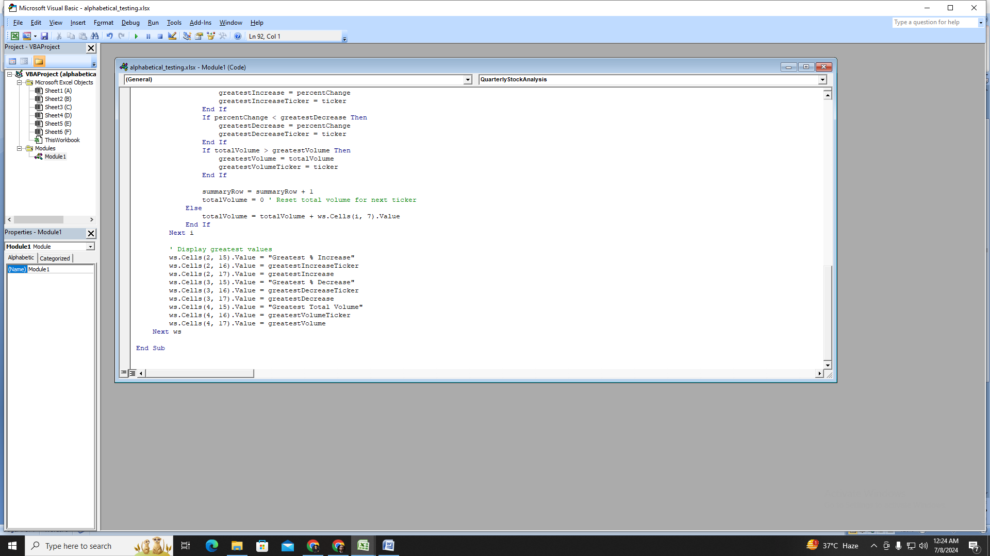

**Multiple Year Stock Analysis**

This script processes stock data across multiple worksheets in the workbook.

**Key Steps:**

1. **Initialize Variables:**
   * Declares variables for ticker symbols, quarterly change, percentage change, total volume, and tracking the greatest values.

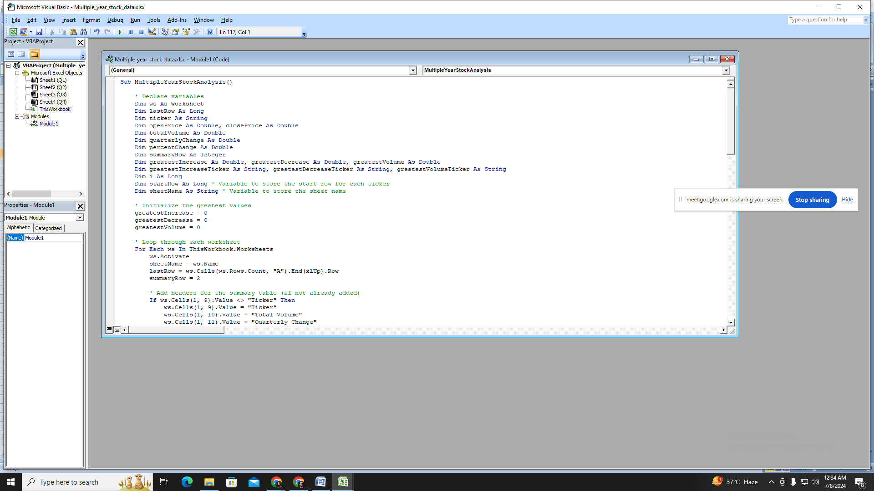

1. **Loop Through Worksheets:**
   * Iterates through each worksheet in the workbook.
   * Adds headers for the summary table if they are not already present.

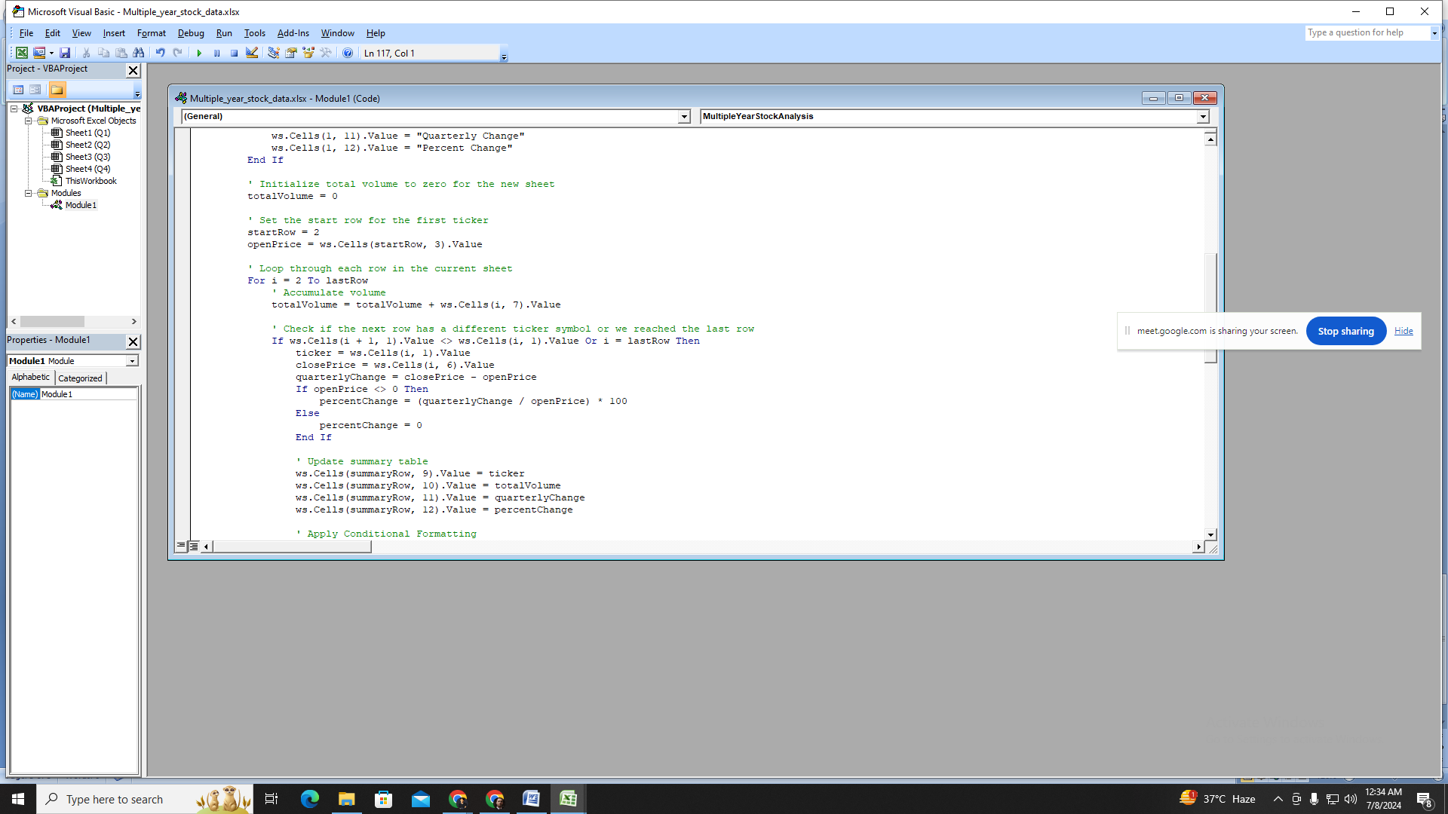

1. **Process Each Row:**
   * Loops through each row of data in the current worksheet.
   * Accumulates the total volume for the current ticker.
   * Calculates the quarterly change and percentage change when the ticker changes or the last row is reached.
   * Writes the results to the summary table and applies conditional formatting.

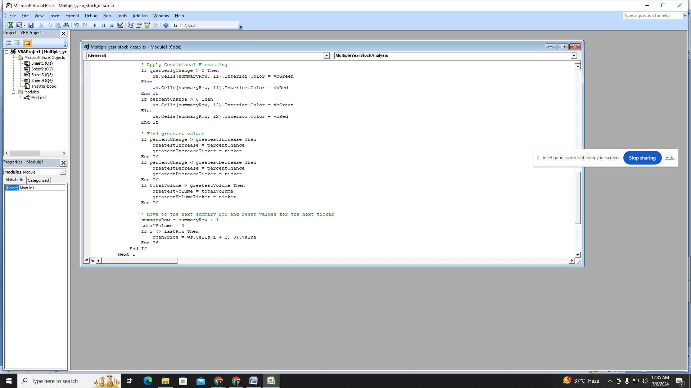

1. **Identify Greatest Values:**
   * Determines the greatest percentage increase, greatest percentage decrease, and greatest total volume.
   * Outputs these values in a designated summary sheet.

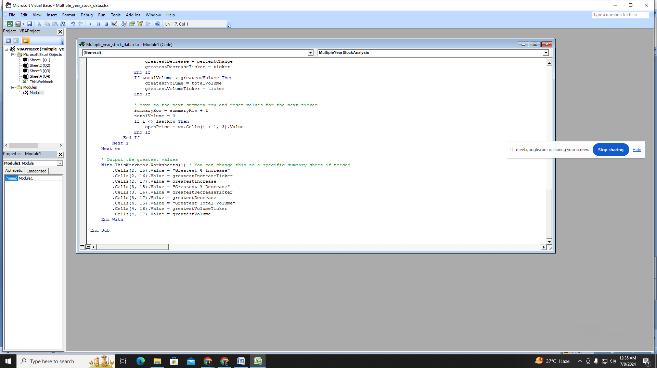

**Sample Output**

The results include:

* Ticker symbol
* Total volume
* Quarterly change
* Percent change
* Conditional formatting for changes

**Single Quarter Stock Analysis**

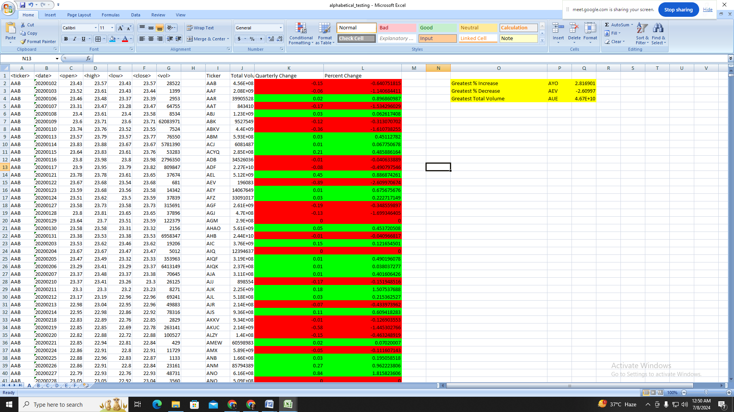

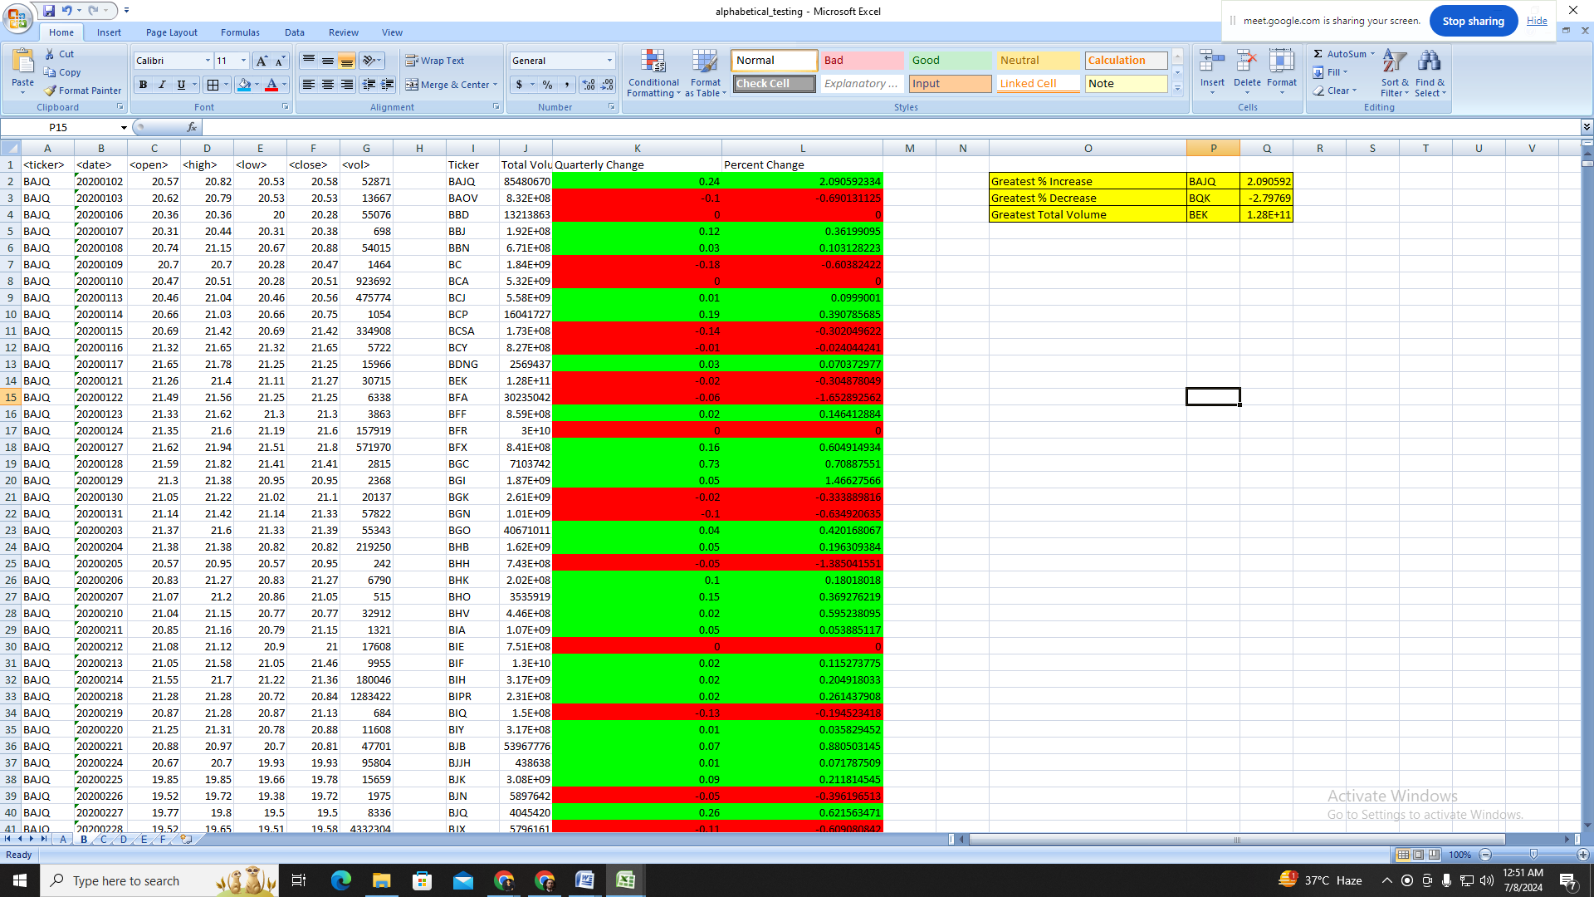

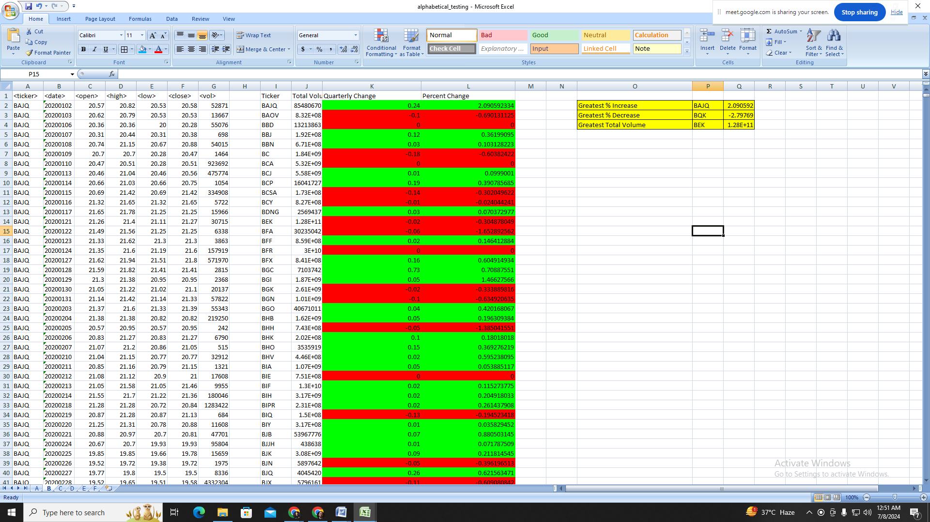

# Multiple Year Stock Data

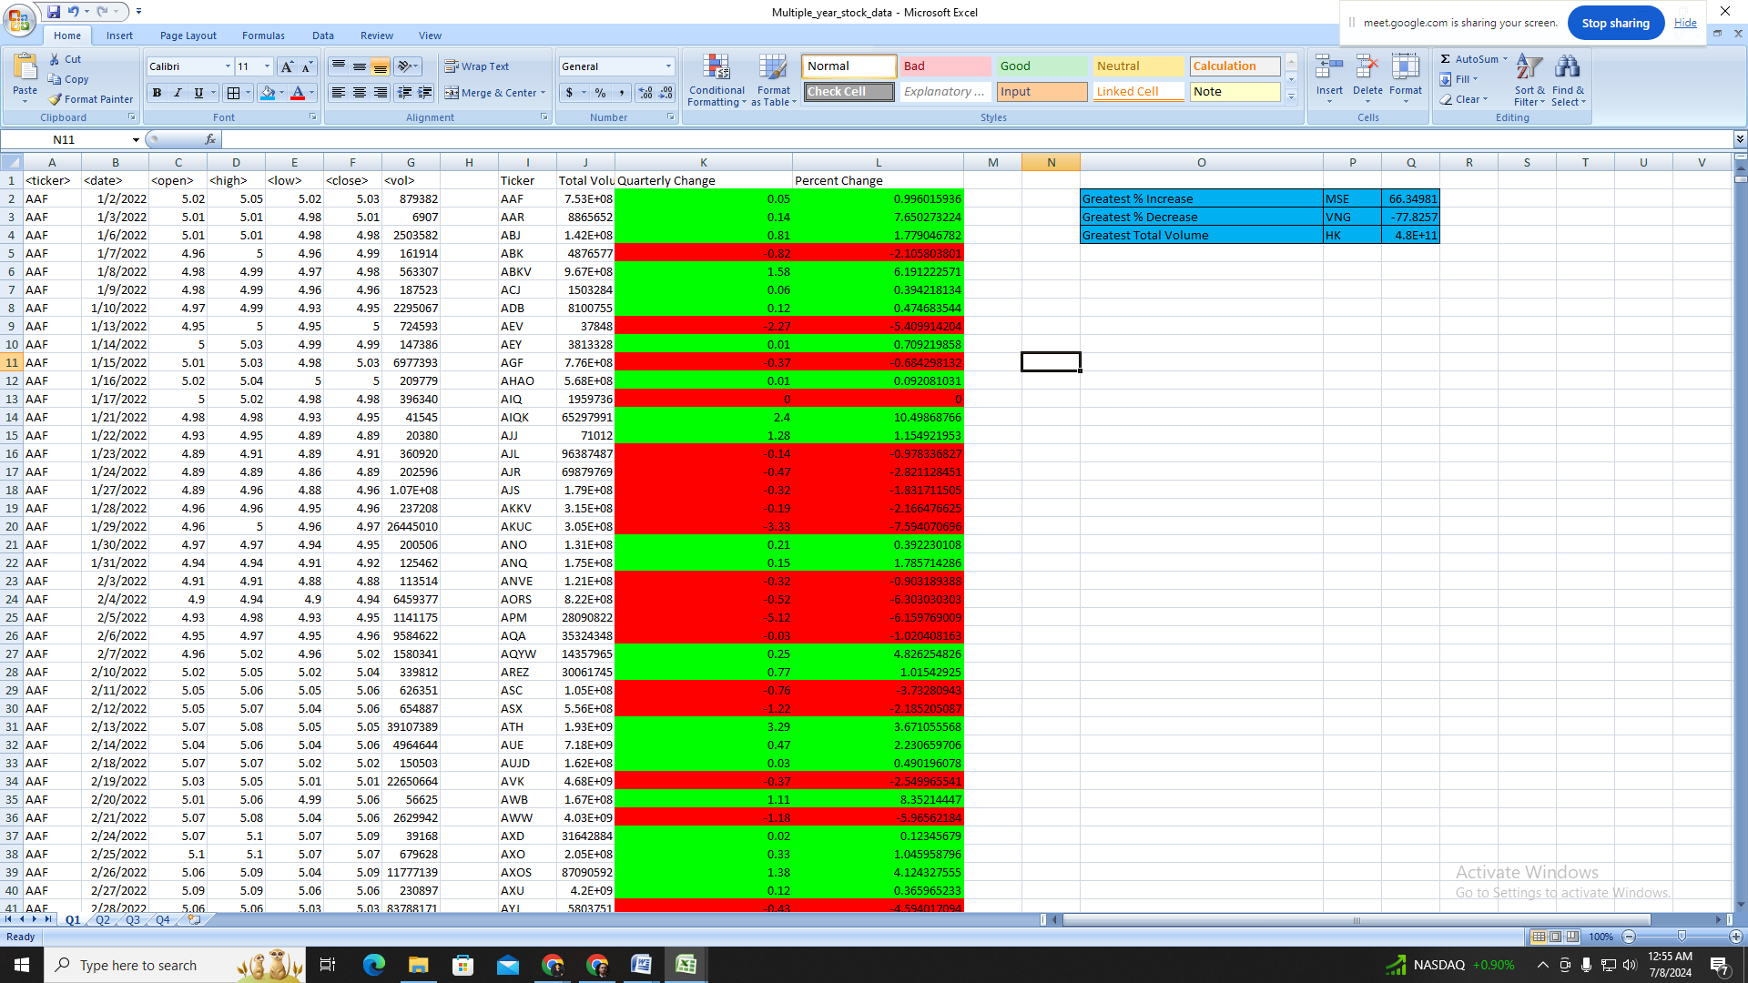

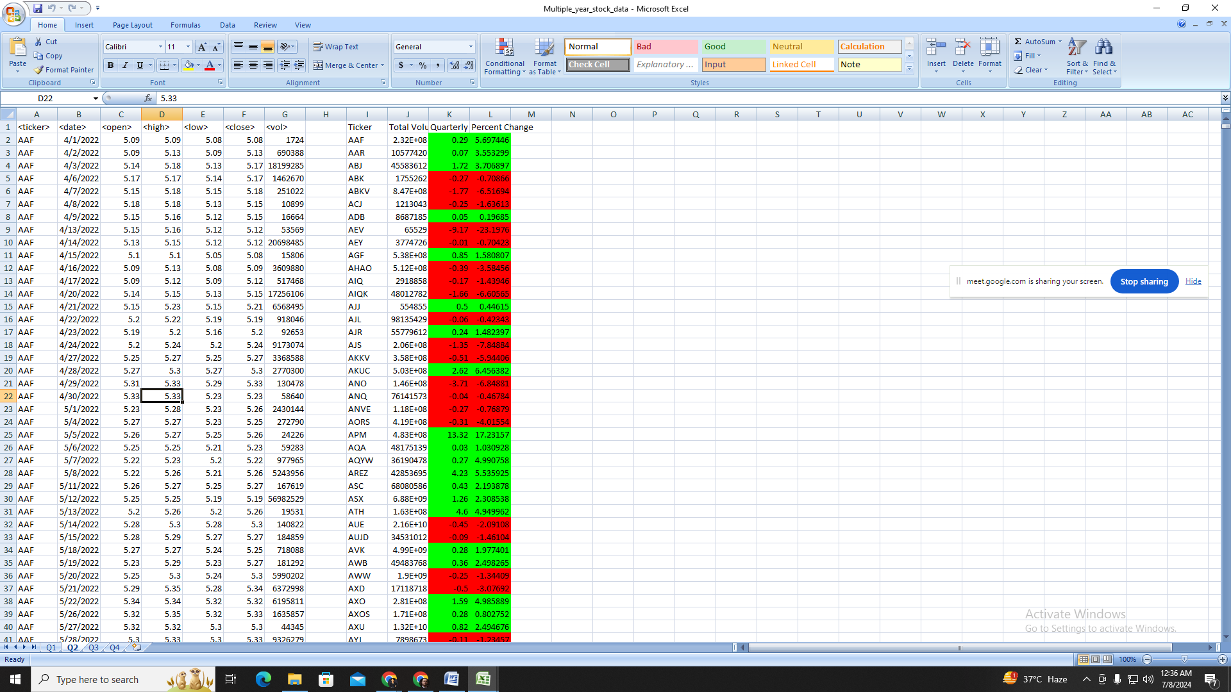

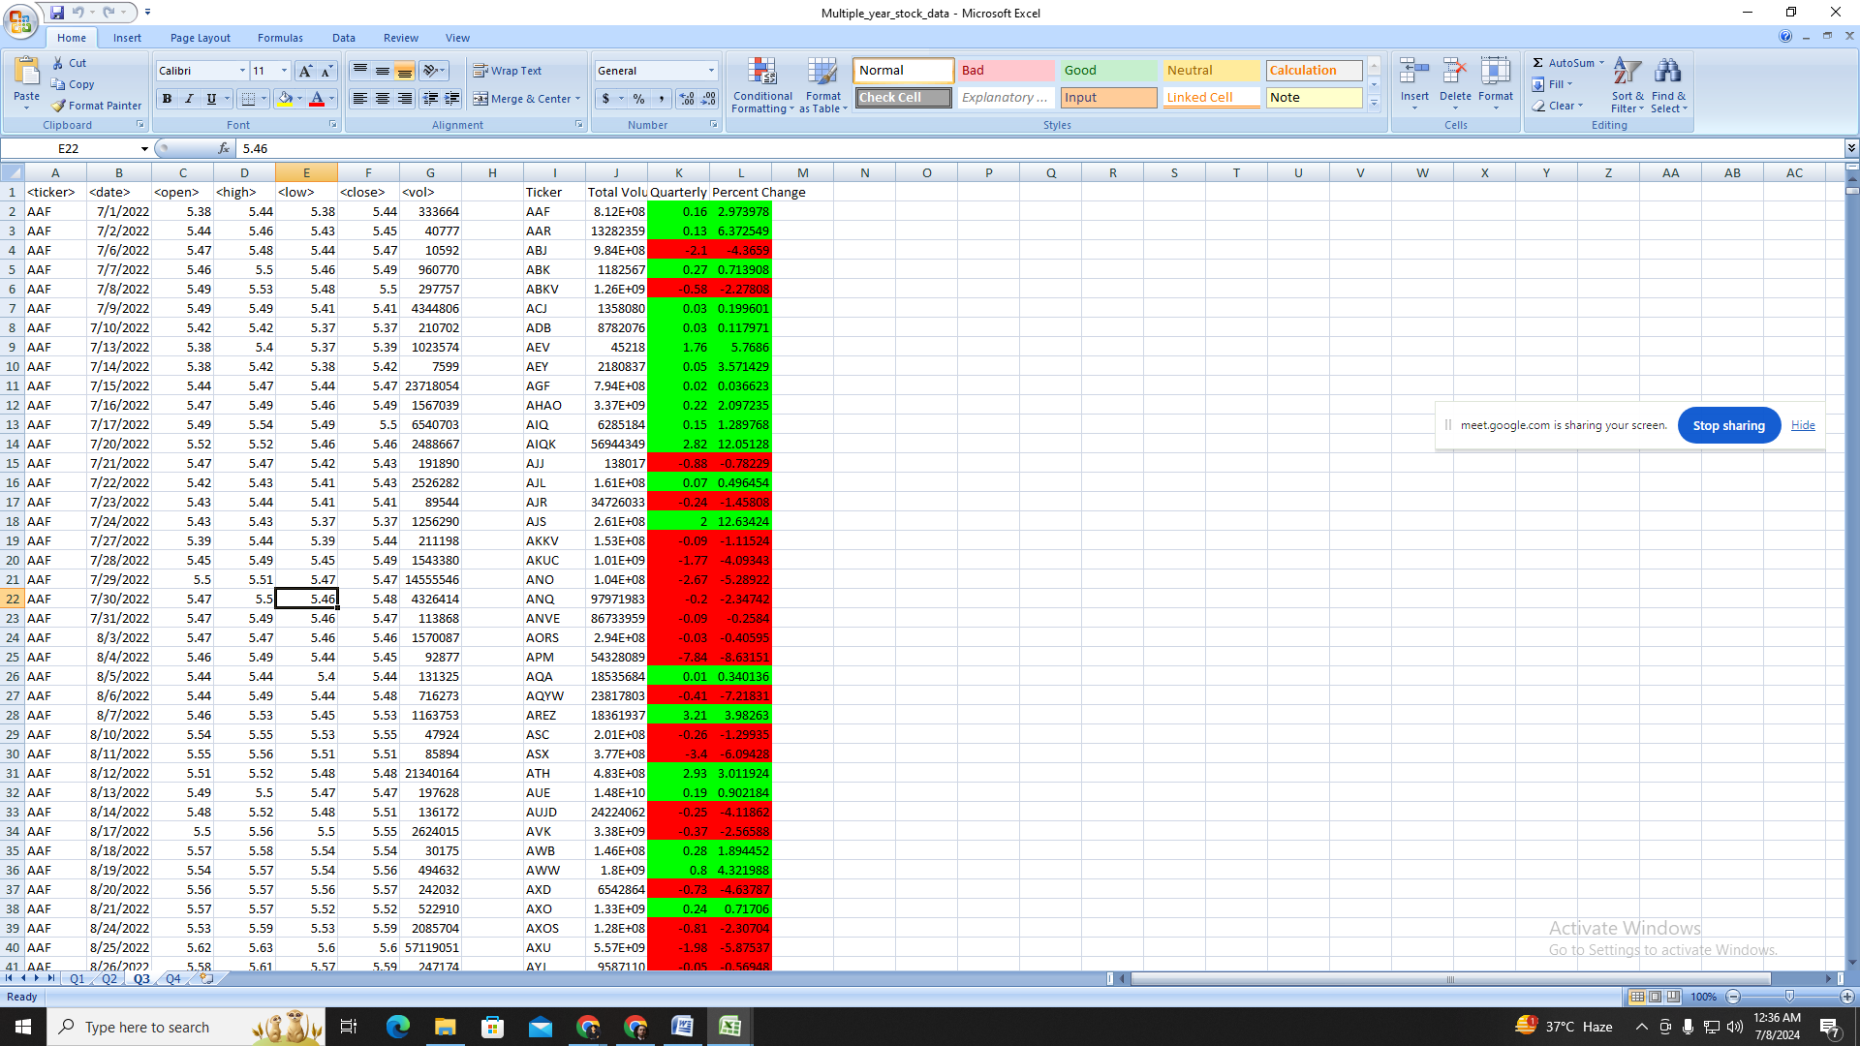

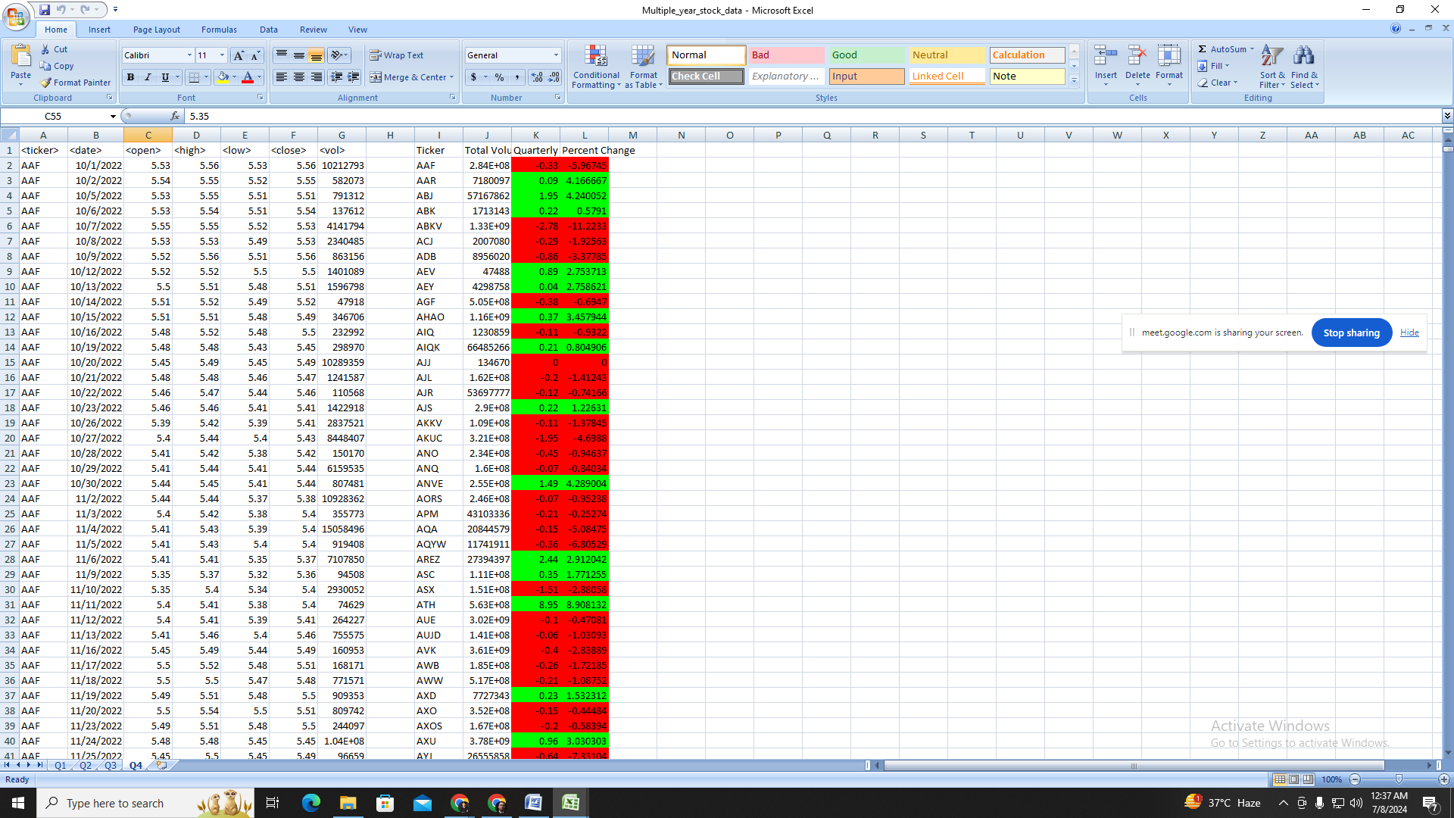

# Summary sheet displays:

* Greatest % Increase
* Greatest % Decrease
* Greatest Total Volume

# alphabetical_testing

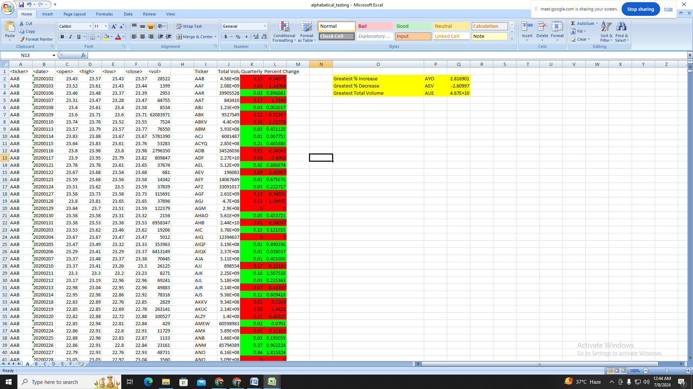

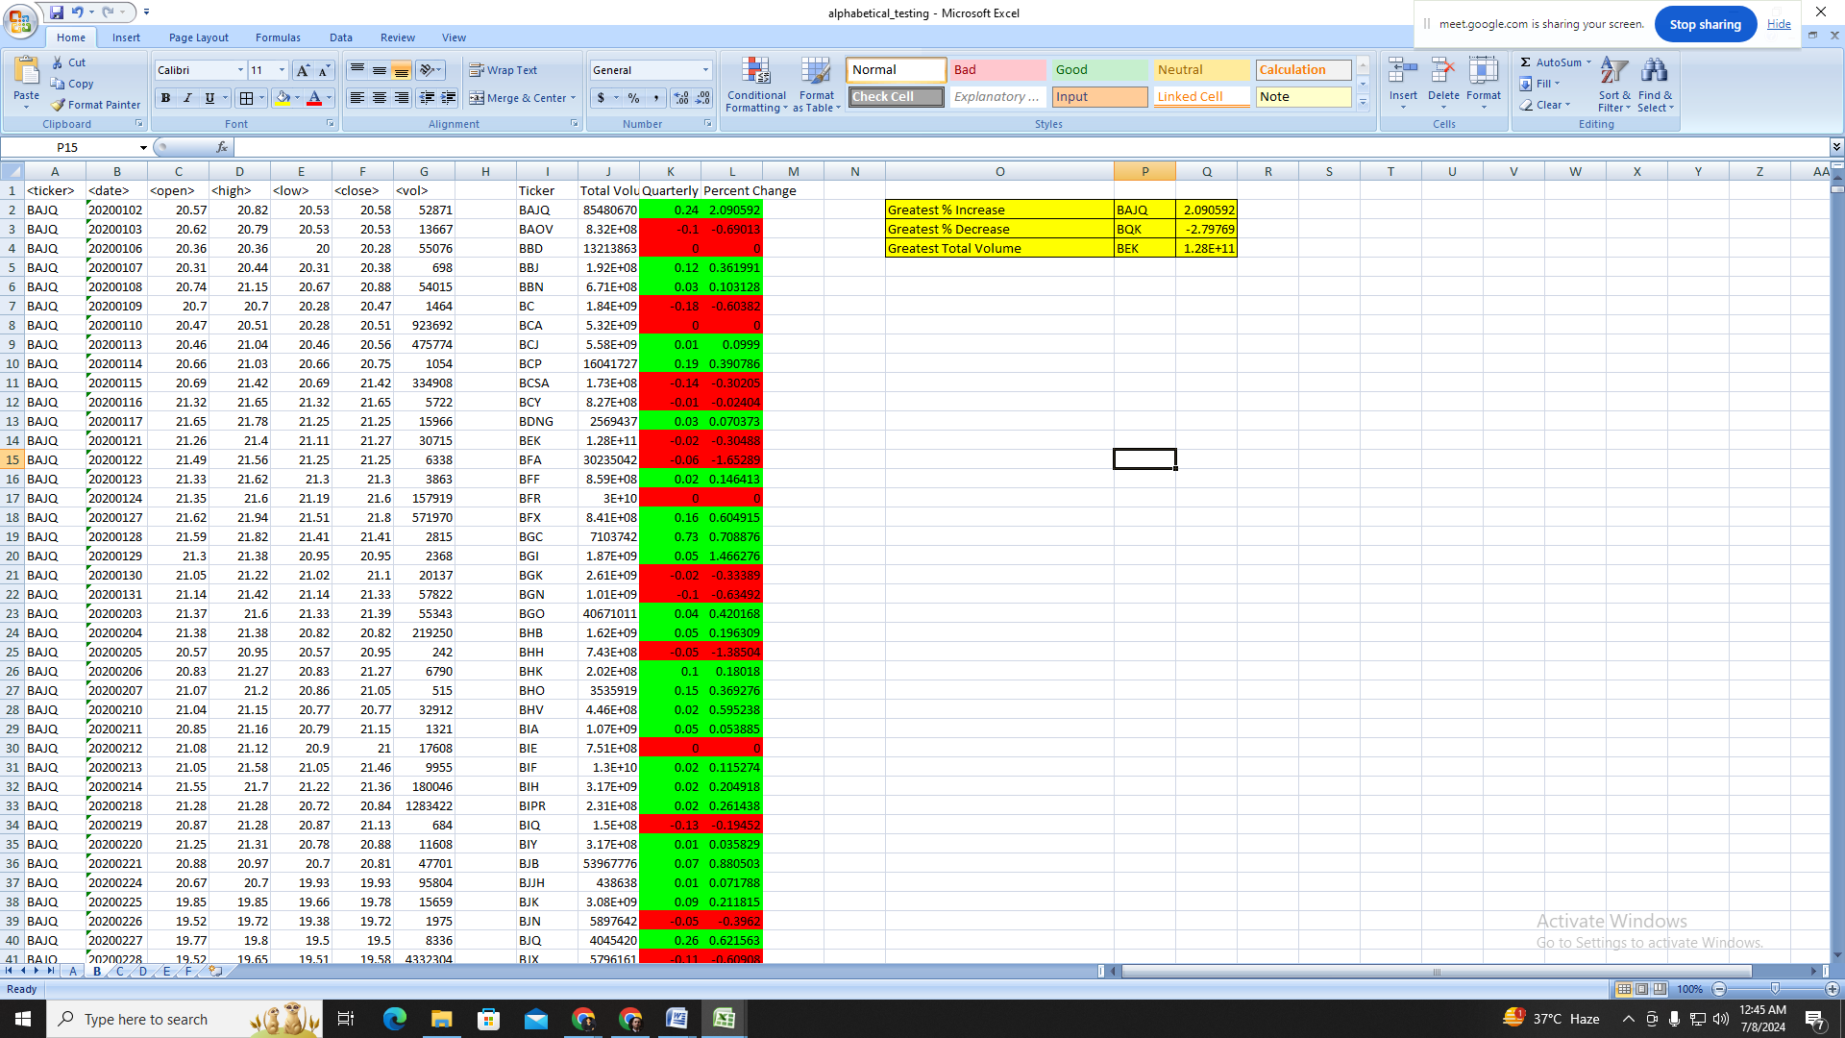

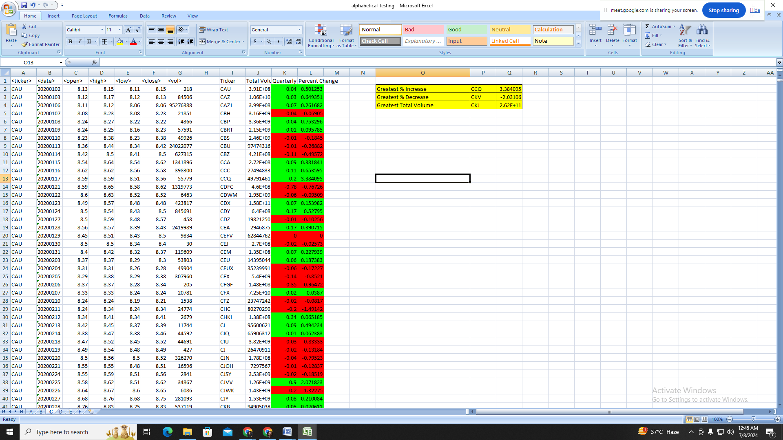

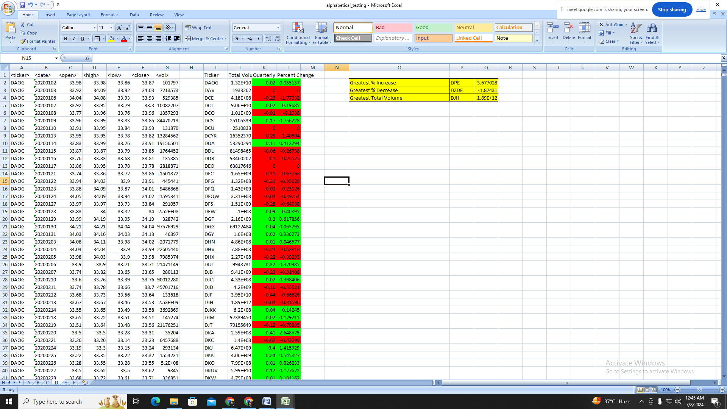

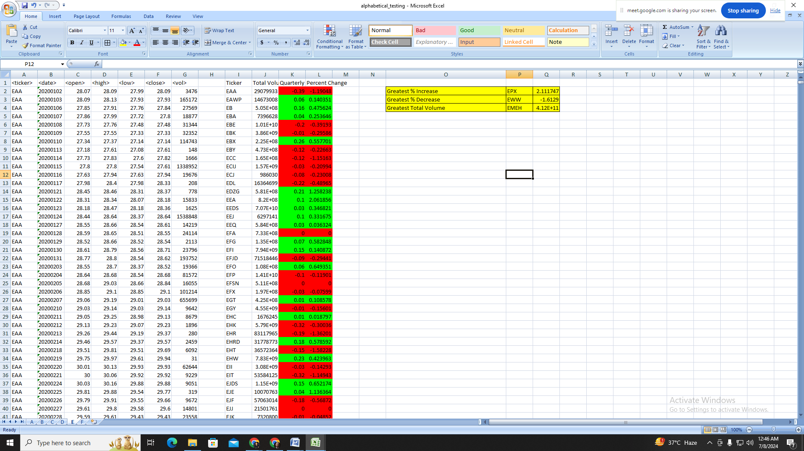

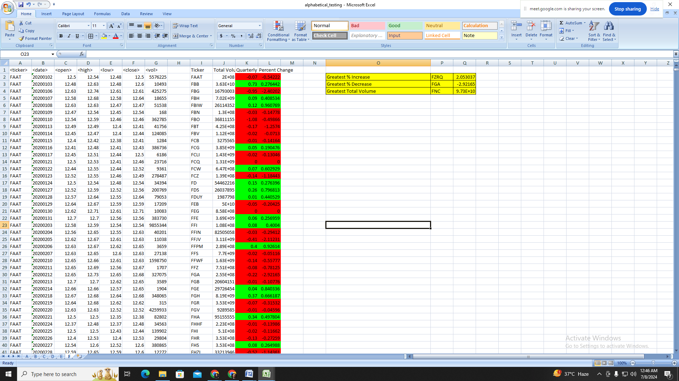

# Multiple Year Stock Data Analysis

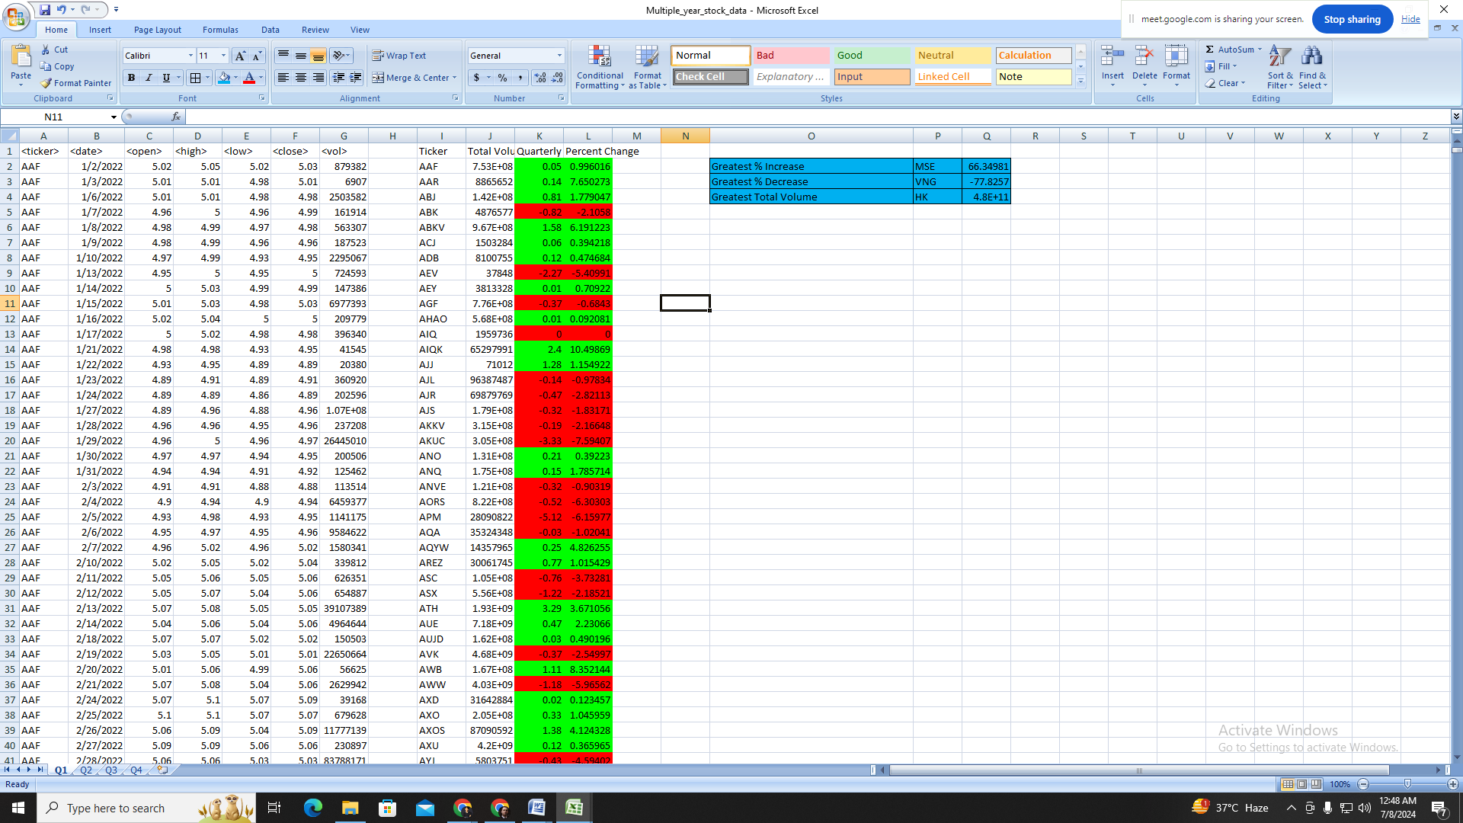

# Conclusion

This project underscores the transformative power of VBA for automating complex data analysis tasks in Excel, particularly in the financial sector. Through the development of robust scripts, we streamlined the calculation of key financial metrics such as quarterly change, percentage change, and total stock volume for multiple stock tickers across various worksheets. The automation not only expedited the data processing but also ensured accuracy and consistency, significantly reducing the manual effort required. By identifying the stocks with the greatest percentage increases, decreases, and total volumes, the scripts provided crucial insights into stock performance. The implementation of conditional formatting enhanced the readability of results, making data interpretation more intuitive. Throughout this project, we gained valuable experience in VBA programming, debugging, and performance optimization, reinforcing the importance of efficient coding practices. Additionally, using GitHub for version control highlighted the benefits of maintaining an organized codebase. This project not only achieved its objectives but also laid a foundation for future enhancements, such as integrating a user-friendly interface to further increase accessibility for non-technical users.

# References

1. Microsoft Corporation, 2023. VBA - Visual Basic for Applications. Available at: <https://docs.microsoft.com/en-us/office/vba/api/overview/excel> [Accessed 8 July 2024].
2. Alexander, M. and Walkenbach, J., 2018. Excel VBA Programming For Dummies. Hoboken, NJ: Wiley.
3. Mansfield, R., 2016. Mastering VBA for Microsoft Office 2016. Indianapolis, IN: Sybex.
4. Fairhurst, D.S., 2017. Financial Modeling in Excel For Dummies. Hoboken, NJ: Wiley.
5. Alexander, M. and Kusleika, D., 2019. Excel 2019 Power Programming with VBA. Hoboken, NJ: Wiley.
6. Sweigart, A., 2019. Automate the Boring Stuff with Python. San Francisco, CA: No Starch Press.
7. Jelen, B. and Syrstad, T., 2010. VBA and Macros: Microsoft Excel 2010. Indianapolis, IN: Que Publishing.